

BAHÇEŞEHİR UNIVERSITY
FACULTY OF ENGINEERING

DEPARTMENT OF COMPUTER ENGINEERING

SIP PROXY AND SIP AGENT WITH RULE EDITOR

Submitted by
ASLI TERZİOĞLU
1035014

Advisor
Yrd.Doc.Dr.SELÇUK BAKTIR

İSTANBUL, MAY 2015

BAHÇEŞEHİR UNIVERSITY
FACULTY OF ENGINEERING
DEPARTMENT OF COMPUTER ENGINEERING

This project work submitted by Aslı Terzioğlu has been done under my supervision. I hereby state that the work outlined in this report satisfies the requirements of the compulsory “Capstone Project” course, and Aslı Terzioğlu can take the capstone project examination.
Signature and Date
………………………….
Yrd.Doç.Dr. Selçuk Baktır
Aslı Terzioğlu has taken and passed the capstone project examination in our presence on May 29, 2015. We hereby certify that this project work fulfills all requirements of “Capstone Project” course.
THE EXAMINATION COMMITTEE
Committee Member Signature
- ………………………….. ………………………..
- ………………………….. ………………………..
- ………………………….. ………………………..
I have reviewed this capstone project report submitted by E… C…. I hereby endorse the project work described here as a “Capstone Project I.”

Signature and Date
………………………….
Prof. Sadettin Özyazıcı
Chairman of the Dept. of Computer Engineering

SUMMARY

VoIP and SIP technologies popularity has been started at last years. SIP applications
will have an important place in the future. VoIP/SIP security technologies unknown as
much as TCP/IP’ s security world. Hence, VoIP/SIP security technologies,
developments and researches are very important for academic and commercial.
In this capstone project, VoIP architecture were examined, the protocols used in this technology have been mentioned in detail.
The main purpose of this study is to ensure the control of VOIP communications that provided by the SIP messages between two users through the server. This is provided in accordance with rules which determine by user. When coming from another that user's approval is not or undesirable methods and media format, rule is checked and refusal is given to packet.

ÖZET

VoIP ve SIP teknolojileri ,son yıllarda oldukça popüler olmaya başlamıştır. Gelecek
iletişim teknolojisi öngörülerinde SIP uygulamalarının, önemli bir yere sahip olacağı
şüphesizdir. Bu popülerliğin artması ile VoIP/SIP dünyasında güvenlik teknolojileri
henüz TCP/IP dünyasındaki kadar olgunlaşmamış ve bilinmemektedir. Bu nedenlerde
dolayı hem ticari hem de akademik anlamda mevcut VoIP/SIP güvenlik teknolojilerinin araştırma geliştirme çalışmalarına önem verilmesini oldukça önemli değer taşımaktadır.
Bu bitirme projesi çalışmasında, VoIP mimarisi incelenmiş, bu teknolojide kullanılan protokoller ve çalışma şekillerine değinilmiş özellikle SIP(Session Inititiaon Protocol) ‘in çalışma şekli ayrıntılı bir şekilde incelenmiştir.
Çalışmadaki asıl amaç, iki kullanıcı arasındaki sunucu üzerinden SIP mesajları ile sağlanan VOIP iletişiminin kullancının belirlediği kurallar doğrultusunda kontrollünü sağlamaktır. Kullanıcının onay vermediği başka kullanıcıdan gelen veya istenmeyen method ve medya formatı geldiği zaman kurala bakıp ,pakete red cevabı veriliyor.

ACKNOWLEDGEMENTS

I want to thank my Capstone Project advisor Yrd.Doç.Dr.Selçuk Baktır on helping and guiding me on my project and Netas Arge Business Development Manager Ugur ÇAĞAL, Hakan KILINÇ, Ali KATKAR and every single person who helped me on Netaş VOIP Security department which allows to studies on this topic and which is always with me when I needed. Also I want to thank to my family and friends who have always supported me during this thesis study.

Aslı Terzioğlu
İstanbul, May 2015

TABLE OF CONTENTS

SUMMARY 1
ÖZET 2
ACKNOWLEDGEMENTS 3
TABLE OF CONTENTS 4
LIST OF FIGURES AND TABLES 5I
TERMINOLOGY 7I
1 INTRODUCTION 1
2 OVERVIEW OF SIP 2
2.1 Basic Architecture 2
2.2 A Typical Successful SIP Call Flow 3
3 SIP MESSAGES AND SESSION DESCRIPTION PROTOCOL 6
3.1 Request Messages 6
3.1.1 Request Message Format 6
3.1.2 SIP Request Types 7
3.2 Response Message 8
3.2.1 Response Message Format 8
3.2.2 Response Messge Types 9
3.3 Session Description Protocol (SDP) 10
4 SIP ARCHITECTURE ELEMENTS 11
4.1 SIP Agents 11
4.2 SIP Server 11
4.2.1 Proxy Server 12
4.2.2 Registrar Server 12
4.2.3 Redirect Server 12
5 RULES EDITOR 13
6 PROPOSED SIP SERVER AND USER CLIENT WITH RULE EDITOR 13
6.1 Overview 13
6.2 Development Phases 14
6.3 Proxy Server and User Agent Interface 16
7 CONCLUSION 21
8 APPENDIX 21
9 REFERENCES 22
10 Curriculum Vitae 23

LIST OF FIGURES AND TABLES
Figure 1 A Typical Call Flow with Proxy Server 3
Figure 2 A Typical SIP Call without Proxy Server 5
Figure 3 SIP Client Configuration 16
Figure 4 SIP Client Messages Table 17
Figure 5 Rule Editor 18
Figure 6 Invite not Accepted 18
Figure 7 SIP Client Registration to SIP Proxy 19
Figure 8 Registered Clients 20

TERMINOLOGY

Peer to peer (P2P): An Internet-based networking option in which two or more computers connect directly to each other to communicate and share files without use of a central server.

SIP client (client): Any network client that sends SIP requests and receives SIP responses. Clients may or may not interact directly with a human user. User agent clients (UACs) and proxies are clients.

SIP header (header): A component of a SIP message that conveys information about the SIP message. It is structured as a sequence of header fields.

SIP message: Data sent between SIP elements as part of the protocol. SIP messages are either requests or responses.

SIP method: The method is the primary function that a SIP request is meant to invoke on a UAS. The method is carried in the request message itself. Example methods are INVITE and BYE.

SIP registrar (registrar): A server that accepts REGISTER requests and places the information it receives from those requests into the location service for the domain it handles.

SIP request (request): A SIP message sent from a UAC to a UAS for the purpose of invoking a particular operation.

SIP response (response): A SIP message sent from a UAS to a UAC, indicating the status of a request sent from the UAC to the UAS.

SIP transaction: A SIP transaction occurs between a UAC and a UAS. The SIP transaction comprises all messages from the first request sent from the UAC to the UAS up to a final response (non-1xx) sent from the UAS to the UAC. If the request is INVITE, and the final response is a non-2xx, the SIP transaction also includes an ACK to the response. The ACK for a 2xx response to an INVITErequest is a separate SIP transaction.

User agent client (UAC): A logical entity that creates a new request, and then uses the client transaction state machinery to send it. The role of UAC lasts only for the duration of that transaction. In other words, if a piece of software initiates a request, it acts as a UAC for the duration of that transaction. If it receives a request later, it assumes the role of a user agent server (UAS) for the processing of that transaction.

User agent server (UAS): A logical entity that generates a response to a SIP request. The response accepts, rejects, or redirects the request. This role lasts only for the duration of that transaction. In other words, if a piece of software responds to a request, it acts as a UASfor the duration of that transaction. If it generates a request later, it assumes the role of a UAC for the processing of that transaction.

INTRODUCTION
This document is a progress report that includes the brief summary of the Session Initiation Protocol (SIP) with the evaluation of current SIP agent software in order to clarify the proposed system, a Java based SIP server and SIP user agent with Rule Editor. The aim of the report is demonstrating the effort of the author, Aslı Terzioğlu, in case of the designing and implementing a Java based Session Initiation Protocol (SIP) server and SIP user agent with Rule Editor for undergraduate project.

Thesis Outline
The outline of this thesis is as follows:
Section 2 represents the general overview of SIP architecture and a basic SIP call flow.

Section 3 describes SIP messaging which request-response methods and the session description protocol (SDP) are examined to highlight the protocol architecture.

Section 4 introduces the description of SIP user agents and server behaviors are introduced to illustrate the different operations of SIP agents.

Section 5 describes that Before focusing on the proposed system, Rules editor is determined that check incoming messages and decides actions by allowing calls to go through or terminating them based on call criteria user specify.

Section 6 clarify a detail specification of the proposed user agent is represented with the discussion of interoperability of the agent in different environments.

Section 7 presents conclusions about work carried during and end of progress of project. A conclusion with one appendix is attached to the end of the report.

OVERVIEW OF SIP

Basic Architecture
Session Initiation Protocol (SIP) is an application-layer control (signaling) protocol for creating, modifying and terminating multimedia sessions with one or more participants and standardized by the Internet Engineering Task Force (IETF) in March 1999. These sessions include Internet multimedia calls, Internet telephone conferences and multimedia distribution.

Thanks to this protocol, establishing and modifying peer to peer multimedia sessions independently of underlying transport protocols and characteristic of session that is being established.

SIP is an ASCII or text-based protocol, similar to HTTP or SMTP, which makes it more lightweight and flexible than other signaling protocols (such as H.323). SIP is also similar to these other protocols in that it uses Universal Resource Identifiers (URIs) for identifying users.A URI identifies resources on the Internet, just as a Uniform Resource Locator (URL) is used to identify Web sites.The URI used by SIP combines a phone number or name, such as SIP: user@domain.com, which makes reading SIP addresses easier.
The Session Initiation Protocol works with two fundamental components :
- User agents, which are endpoints of a call (i.e., each of the participants in a call).
- SIP servers, which are computers on the network that service requests from clients, and send back responses.

In SIP architecture ,there are two types of network communications that requests are processed in different ways. One of them is Client/Server communication which they simply send requests that are processed by a specific server. The other is Peer-to-peer which one acts as a User Agent Client, and the other fulfills the request acts as a User Agent Server.

A Typical Successful SIP Call Flow
SIP messages initiated In the user agent clients are reached directly one or more SIP user agents clients. However, SIP user agents can also communicate with SIP proxy servers.

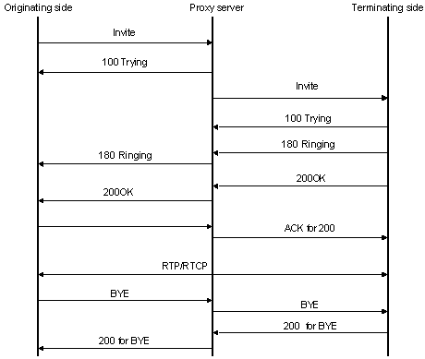
Figure 1 A Typical Call Flow with Proxy Server

Given below is a step-by-step explanation of the above call flow:

1. An INVITE request that is sent to a proxy server is responsible for initiating a session.
2. The proxy server sends a 100 Trying response immediately to the caller (User1) to stop the re-transmissions of the INVITE request.
3. The proxy server searches the address of User2 in the location server. After getting the address, it forwards the INVITE request further.
4. Thereafter, 180 Ringing (Provisional responses) generated by User2 is returned back to User1.
5. A 200 OK response is generated soon after User2 picks the phone up.
6. User2 receives an ACK from the User1, once it gets 200 OK.
7. At the same time, the session gets established and RTP packets (conversations) start flowing from both ends.
8. After the conversation, any participant (Alice or Bob) can send a BYE request to terminate the session.
9. BYE reaches directly from Alice to Bob bypassing the proxy server

A Basic Call Flow without Proxy Server
The following figure represents the initiation of a SIP session between two user agents. Initially, with User2’s soft phone sending INVITE request to User1’s URI address. The INVITE request message contains of header fields that provide necessary information about the caller party and the type of session.

As soon as the User2’s SIP phone receives the INVITE message from User1, it informs User2 about the incoming request. The User1 send a Ringing message (180 Ringing) to User2. The called agent is free to accept or cancel any incoming request, but in this particular User1 accepts to answer the request and sends OK message (200 OK) to User2. When the User2 receives the OK message, it sends the message (ACK) to the user1 in order to notify the caller agent.After that,the session is created and both parties begin to send multimedia packets based on the Real Time Protocol. These packets may take different routing paths from the initial signaling messages. During the session either User1 or User2 decides to change the characteristic of the session, enhancing the multimedia features or modifying the agents capabilities.

When either of the user agents decides to conclude the session, he uses BYE message to notify the other party about the situation. Finally, User2 disconnects first and the BYE message (BYE) is sent directly to User1 soft phone . User1 confirms the end of session by a OK message (200 OK) and the session is ended.

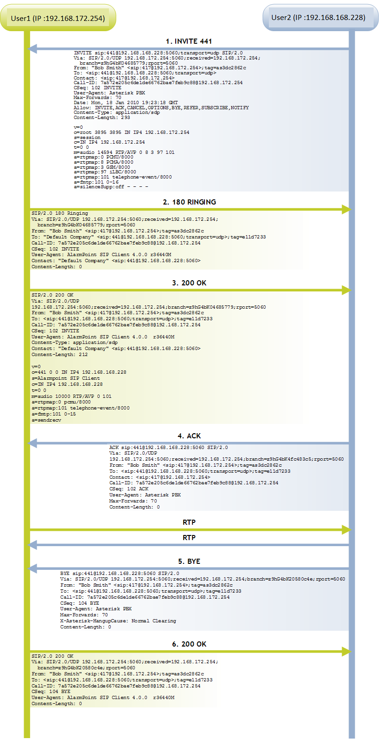
Figure 2 A Typical SIP Call without Proxy Server

SIP MESSAGES AND SESSION DESCRIPTION PROTOCOL
SIP is a text-based protocol and uses the ISO 10646 character set in UTF-8 encoding. There are two types of SIP Messages, SIP Request and SIP Response Messages.
Message format generally as follows:

<request start line>
<request headers> (several lines)
<blank line>
<message body> (carries the Session Description Protocol message)

Request Messages

Request Message Format
A SIP request messages sent from a UAC to a UAS for the purpose of invoking a particular operation.
A sample request message:
INVITE sip:user2@server2.com SIP/2.0
Via: SIP/2.0/UDP pc33.server1.com;branch=z9hG4bK776asdhds
Max-Forwards: 70 To: user2 <sip:user2@server2.com>
From: user1 <sip:user1@server1.com>;tag=1928301774
Call-ID: a84b4c76e66710@pc33.server1.com
CSeq: 314159 INVITE
Contact: <sip:user1@pc33.server1.com>
Content-Type: application/sdp
Content-Length: 142
---- User1 Message Body Not Shown ----

The first line is called Request-Line. This line includes name of methods and through this line is defined messages that request message.
Via : It contains caller’s local adress where response message will be considered.
To: It include the callee’s nameand SIP URI information.
From: It includes user1 SIP URI information.In addition ,random series are added to tag field by the SIP application.it used to identify the caller.
Call-ID: A unique value for each call.It is formed by a random string value and IP adress.

Each dialog is defined as the combination of the From ,To and Call-ID.
CSeq: When transaction starts ,the first will be given a cseq number. Thereafter it increased with each new message.It used to detect out of its aim messages andnon-delivered messages.
Contact: It includes SIP URI which direct route of User1.This header also contain username ,domain name and IP address information.
Although Via header is used for sending a message which response to a request ,Contact header is used for sending future requests.
Content-Type: It contains a description of the message body.
Content-Length: The length of bytes in the message body.
Record-Route: The Record-Route header is inserted into requests by proxies that want to be in the path of subsequent requests for the same call-id. It is then used by the user agent to route subsequent requests. The mechanism is similar to a source-route, copying the Record-Route information into a set of Route headers. The RequestURI is set to the first Route header.

Message header may contain different fields. However, these fields are optional. The body of the message session description protocol (SDP) is used to transmit the written media and protocol information.

SIP Request Types
INVITE → Indicates a client is being invited to participate in a call session.
ACK → This message acknowledges receipt of a final response to INVITE. Establishing of a session utilizes 3-way hand-shaking due to asymmetric nature of the invitation. It may take a while before the callee accepts or declines the call so the callee's user agent periodically retransmits a positive final response until it receives an ACK (which indicates that the caller is still there and ready to communicate).
BYE → Bye messages are used to tear down multimedia sessions. A party wishing to tear down a session sends a BYE to the other party.
CANCEL → Cancel is used to cancel not yet fully established session. It is used when the callee hasn't replied with a final response yet but the caller wants to abort the call (typically when a callee doesn't respond for some time).
OPTIONS → Queries the capabilities of servers.
REGISTER → Purpose of REGISTER request is to let registrar know of current user's location. Information about current IP address and port on which a user can be reached is carried in REGISTER messages. Registrar extracts this information and puts it into a location database. The database can be later used by SIP proxy servers to route calls to the user. Registrations are time-limited and need to be periodically refreshed.
PRACK → Provisional acknowledgement.
SUBSCRIBE → Subscribes for an event of notification from the notifier.
NOTIFY → Notify the subscriber of a new event.
PUBLISH → Publishes an event to the server.
INFO → Sends mid-session information that does not modify the session state.
REFER → Asks recipient to issue SIP request (call transfer.)
MESSAGE → Transports instant messages using SIP.
UPDATE → Modifies the state of a session without changing the state of the dialog.

Response Message

Response Message Format
When a user agent or proxy server receives a request it send a reply.

A typical response message:
SIP/2.0 200 OK
Via: SIP/2.0/UDP site4.server2.com;branch=z9hG4bKnashds8;received=192.0.2.3
Via: SIP/2.0/UDP site3.server1.com;branch=z9hG4bK77ef4c2312983.1;received=192.0.2.2
Via: SIP/2.0/UDP pc33.server1.com;branch=z9hG4bK776asdhds;received=192.0.2.1
To: user2 <sip:user2@server2.com>;tag=a6c85cf
From: user1 <sip:user1@server1.com>;tag=1928301774
Call-ID: a84b4c76e66710@pc33.server1.com
CSeq: 314159 INVITE
Contact: <sip:user2@192.0.2.4>
Content-Type: application/sdp
Content-Length: 131
---- User2 Message Body Not Shown ----

Responses are very similar to the requests, except for the first line. The first line of response contains protocol version (SIP/2.0), reply code, and reason phrase.In the response message ,the first line is called the Status Line that the SIP version (SIP/2.0) ,the status code and descriptive(200 OK ) are located.

Following the other lines is similar to the request message.The additions are as follows:

One or more via headers can be found. A SIP request can contain one or more Via header fields which are used to record path of the request. They are later used to route SIP responses exactly the same way. The INVITE message contains just one Via header field which was created by the user agent that sent the request.
To: This field is a label (tag) contains.This tag is used to represent the called party.
Contact: It contains the User2 's complete address. Thus, in subsequent requests , User1 does not need proxy servers to find User2.

Response Messge Types
There are 6 types of responses:
1xx: Informational - request received, continuing to process the request
2xx: Success - the action was successfully received, understood, and accepted
3xx: Redirection - further action needs to be taken in order to complete the request
4xx: Client Error - the request contains bad syntax or cannot be fulfilled at this server
5xx: Server Error - the server failed to fulfill an apparently valid request
6xx: Global Failure -- the request cannot be fulfilled at any server.
SIP responses are extensible. SIP applications don’t have to know all of the registered response codes but they have to know and understand their classes.

Some examples of the registered response codes are:
100 – Trying
180 – Ringing
200 – Queued
300 – Multiple Choices
301 – Moved Temporarily
400 – Bad Request
401 – Unauthorized
500 – Internal Server Error
504 – Gateway Time-out
600 – Busy Everywhere
606 – Not Acceptable

Session Description Protocol (SDP)
SDP is intended for describing multimedia sessions for the purposes of session announcement, session invitation, and other forms of multimedia session initiation.
SDP includes the type of media (video, audio, etc.) ,the transport protocol (RTP/UDP/IP, H.320, etc.) ,the format of the media (H.261 video, MPEG video, etc.) ,information to receive those media (addresses, ports, formats and so on).

In each session description some lines are optional (marked with “ * ”) but they have to appear in the order given here:
Session Description:
v= (protocol version)
o= (owner/creator and session identifier)
s= (session name)
i=* (session information)
u=* (URI of description)
e=* (email address)
p=* (phone number)
c=* (connection information – not required if included in all media)
b=* (bandwidth information)
z=* (time zone adjustments)
k=* (encryption key)
a=* (zero or more session attribute lines)
Time description:
t= (time the session is active)
r=* (zero or more repeat times)
Media description:
m= (media name and transport address)
i=* (media title)
c=* (connection information - optional if included at session-level)
b=* (bandwidth information)
k=* (encryption key)
a=* (zero or more media attribute lines)

The caller and callee align their media descriptions so that the nth media stream ("m=" line) in the caller's session description corresponds to the nth media stream in the callee's
description.
All media descriptions should contain "a=rtpmap" mappings from RTP payload types to encoding.

SIP ARCHITECTURE ELEMENTS

SIP Agents
It is the endpoint and one of the most important network elements of a SIP network. An endpoint can initiate, modify, or terminate a session. User agents are the most intelligent device or network element of a SIP network. It could be a softphone, a mobile, or a laptop. User agents are logically divided into two parts:

User Agent Client (UAC): The entity that sends a request and receives a response.

User Agent Server (UAS): The entity that receives a request and sends a response. SIP is based on client-server architecture where the caller’s phone acts as a client which initiates a call and the callee’s phone acts as a server which responds the call.

SIP Server
There are mainly three types of SIP servers:
- Registrars
- Proxy
- Redirect
These servers can be physically separated or combined into one server. So this division is only logical division.

Proxy Server
It is the network element that takes a request from a user agent and forwards it to another user. - Essentially the role of a proxy server is such as a router. A proxy server locates in between two user agents.
There are two types of proxy servers:
→ Stateless Proxy Server: It simply forwards the message received. This type of server does not store any information of a call or a transaction.
→ Stateful Proxy Server: This type of proxy server keeps track of every request and response received and can use it in future if required. It can retransmit the request, if there is no response from the other side in time.

Registrar Server
The registrar server accepts registration requests from user agents. It helps users to authenticate themselves within the network. It stores the URI and the location of users in a database to help other SIP servers within the same domain. Take a look at the following example that shows the process of a SIP Registration

Redirect Server
The redirect server receives requests and search the intended recipient of the request in the location database generated by the registrar. The redirect server uses the database for getting location information and responds with 3xx (Redirect response) to the user.

RULES EDITOR
Rules editor includes severeal specific rules that users craete. Rules editor determine rules to control call traffic in real time, by allowing calls to go through or terminating them based on call criteria user specify.

A rule contains a set of criteria which Action, Source IP, Source Port, Destination IP, Destination Port, Request Method, Response Method, Codec and Bandwidth. Action performed on a packet matching the criteria.It accept or reject.
A complete rule is defined by the ordered tuple
<Action,SrcIP,SrcPort,DestIP,DestPort,RequestMeth,ResponseMeth,Codec,Bandw>
Example:
<Blocked, 192.168.20.5, 5062, 64.233.179.104,5080, INVITE ,ANY ,GSM ,125>
Generally consist of a list of rules is in the form ”if condition then action”, where condition can be e.g., a comparison to criterias such as IP address, port, method, codec, bandwith are either accepting or discarding.

PROPOSED SIP SERVER AND USER CLIENT WITH RULE EDITOR

Overview
The aim of this Project is implementing a SIP User Agent with Rule Editor. It will be implemented using Java and its specialized API’s about this area. The functionality of the program is, simply providing a platform, which enables users of that program to establish sessions with each other.

The client program will work on a PC and be able to connect to another PC running our client program. One of our aims for using Java is the platform independency. This platform independency brings flexibility to our program. The client code will communicate over Internet. The computer not only can have a direct access to Internet, which is the common thing for home users but also can be connected to a LAN. Beside the fact that, different network architectures are available our client program will be capable of establishing calls over either Internet or LAN.

The client program can be used in two ways. Firstly, a user can make a call to another user by directly connecting to his/her User Agent. The users will communicate directly via their SIP addresses. Secondly, there exists another way of establishing calls. The client program can also talk over a Proxy server. The connection can be established first by communicating with a Proxy server, registering and then establishing calls via the Proxy server.

My client program will provide some required services defined in IETF RFC-3261. These functions can be stated as follows: registering with a server, starting a call, making the call, finishing a call, accepting a call. Beside these basic functionalities, the software can be extended to handle extra user-based rules for the SIP messages. These features can be implemented in order to increase the service quality and customer satisfaction.

Development Phases
During the implementation of the SIP User Agent, I plan to have some basic milestones, which I will try to reach in order to fulfill the basic functionalities. First of all my clients will use the Session Initiation Protocol (SIP) in order to establish calls; therefore, I have to follow and be compliant with RFC 3261 . I also want to implement SDP support, which also must be compliant with RFC 4566.

First step, I start to implement a client using Java, which has a graphical user interface to perform desired functions. The software will be able to send and receive text-based messages over Internet or LAN via IP addresses. Since SIP is described as a text-based protocol, communicating via SIP using text-based messages will be my initial step in the project. In other words, by managing to send and receive the messages I can simply send and receive our SIP messages the same way. This is implemented with the State pattern .The State pattern is useful when you have an object that can be in one of several states, with somewhat different behavior in each state. I will examine the program by sending Invite, Ack, Bye … messages between the computers. This part of the program will act as the User Agent Client, which sends text-based SIP Requests in order to establish sessions.

As a second step I plan to implement the Registrar-Proxy Server part. This part should receive to incoming requests and responses, parse and process them and do the necessary work. With the help of this JAIN SIP API we will implement the message parser. After completing this step we will theoretically have finished establishing a session between clients and making calls between them. The initial version of the software will only provide to make, suspend, finish and cancel call operations.

After that I plan to integrate the SIP agent with a SIP Proxy that enables us not only to establish calls directly between known SIP addresses but also indirect addressing schemes defined in SIP specification: e-mail or URL based addressing. In this stage, the client will be able to establish calls by first communicating with Proxy server and the server will be responsible to locate and trigger the call by checking its matching tables.
Blocked
192.168.2.3
5062
192.158.6.3
5012
INVITE
(Any)
RTP/AVP
(Any)
47.168.157.3
5082
192.168.2.3
5092
REGISTER
(Any)
GSM
(Any)
172.132.24.8
5092
192.168.2.3
5082
OPTIONS
200
RTP/AVP
130
47.152.78.12
5062
192.168.78.25
5062
(Any)
200
PCMU
200

Finally, after fulfilling the basic functionalities I will add the tracer window, where I will display the incoming and outgoing SIP messages. After that I plan to implement based user defined Rules Editor where the user will be able to store database. Then I will continue developing the program in order to perform checking incoming messages and rules in database. Basically this will provide simple rejection.

Rules are searching by creating a tree. Average complexity is O(log(n)).The worst case is O(n) in rule tree.

NOTE: UML diagrams can be found the document at the end.

Proxy Server and User Agent Interface
The propose user agent provides a graphical user interface for the user in order to establish, modify and terminate the SIP sessions.
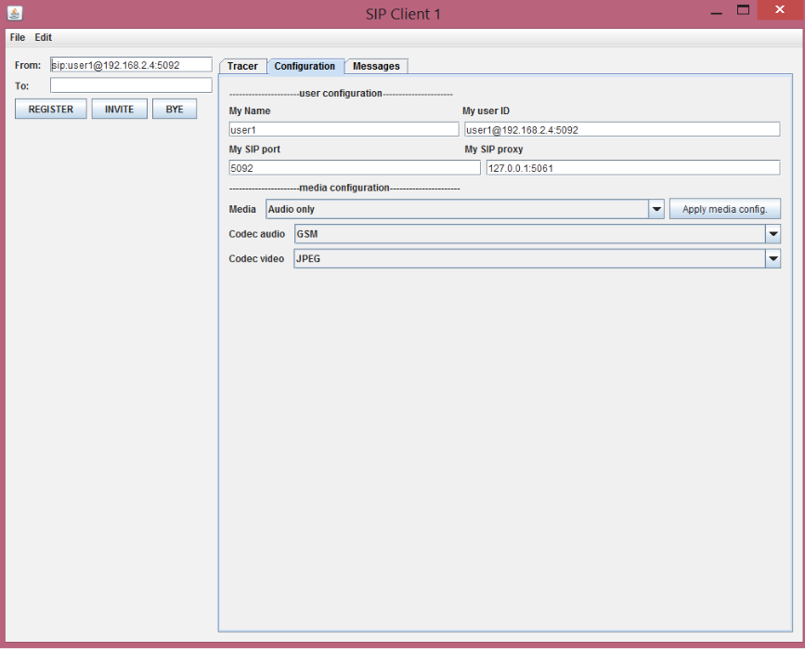
Figure 3 SIP Client Configuration

When the agent is executed, the main screen shown to configuration of the user in the figure 3. The configuration service is the Configuration control panel that enables the user to change the setting and configurations of the agent. In this screen , user settings can be changed.

The following figure shows incoming messages that from other user.There some field are received from of messages.
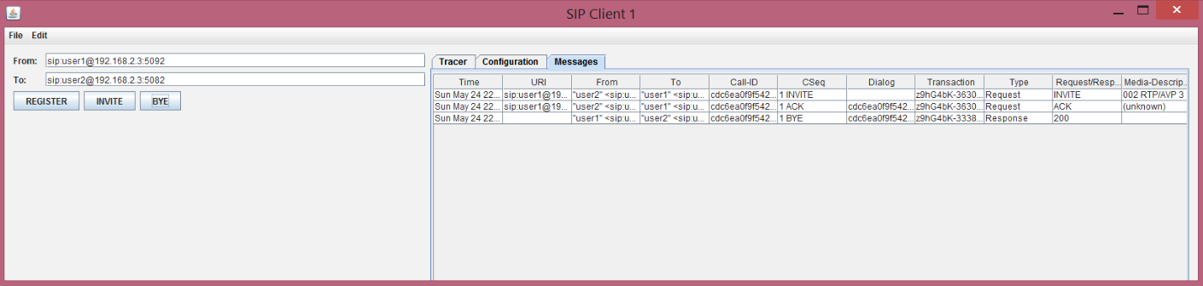
Figure 4 SIP Client Messages Table

Rules editor keeps rules in a table that store in database. Incoming messages are ckecking for compliance with the rules in Figure 5. According to this, if message is in the blocked list(tree), 406 Not Acceptable response is given (Figure 6).
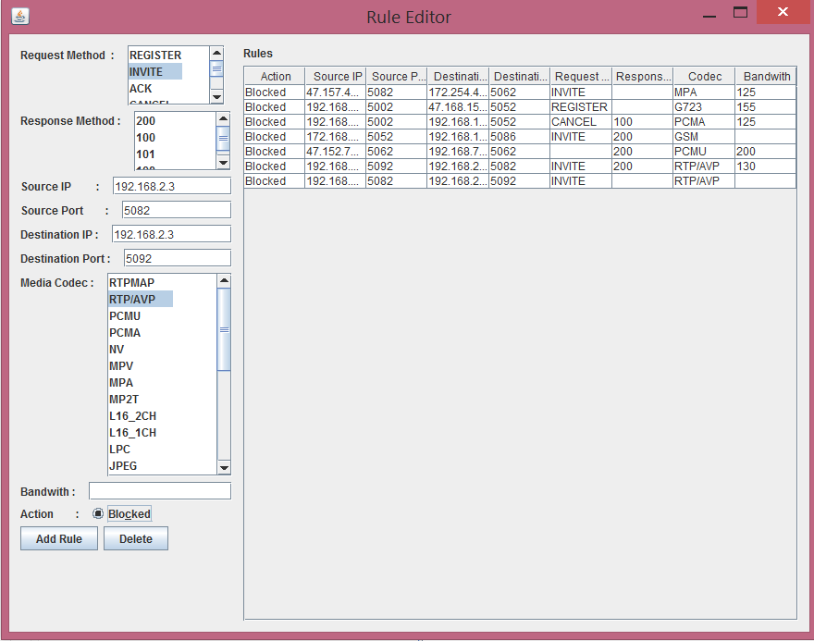
Figure 5 Rule Editor
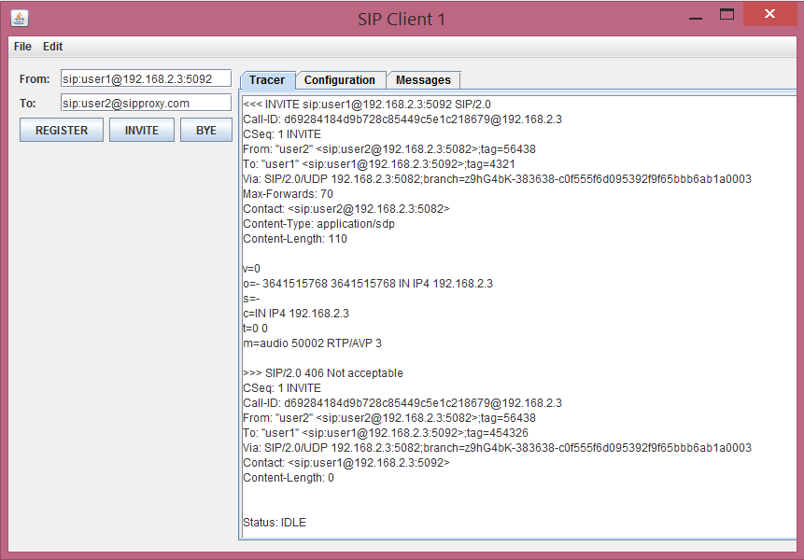
Figure 6 Invite not Accepted

In Figure 7, Every user registers its current location to a REGISTRAR server. The application sends a message called REGISTER informing the server. The Registrar stores this binding (between the user and its present address) in a location server.

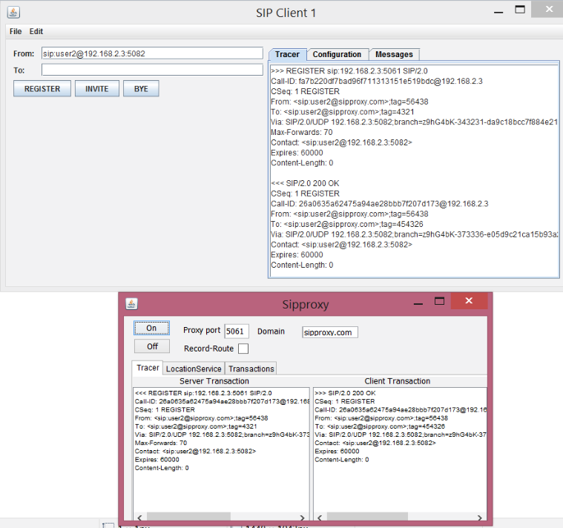
Figure 7 SIP Client Registration to SIP Proxy

After registering to SIP Proxy , user records shows LocationService interface. Then, users can use the domain name through establishing session in Figure 8.

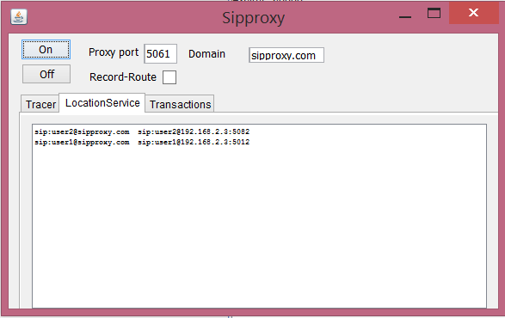
Figure 8 Registered Clients

CONCLUSION
In these report, the aim of the authors is representing their effort in developing a Java based SIP server and SIP user agent with rule editor software. The majority of the report is devoted to the architecture of the protocol and infrastructure of the different agents with the different implementations methods.
In addition to the broad overview of the SIP, protocol, server and client behaviors are explained in the detail for the infrastructure of the proposed system.Finally the proposed system is represented to clarify the author’s intention and efforts in development phases.

APPENDIX
What is the JAIN SIP STACK ?
The JAIN SIP API presents a powerful "SIP stack".The Java APIs for Integrated Networks (JAIN) is a JCP work group managing telecommunication standards. Session Initiation Protocol (SIP) is a standard communication protocol, discussed in a previous article. Put Java and SIP together and you get the JAIN SIP API, a standard and powerful API for telecommunications. This idea started in 1999 with JSR 32. The reference implementation is open source, very stable, and very widely used. If you're writing a SIP application with Java, using this SIP stack makes perfect sense.
The proposed user agent client will be implemented by using the JAIN SIP API ^{[7]} that is released in December 2001. The API focuses around the SipListener and SipProvider interfaces. A SipListener implementation must be part of any JAIN SIP application in order to receive messages, and an application uses a SipProvider to send SIP messages into the network. The SipProvider interface defines the methods required to send SIP messages. It also defines the methods required to maintain a list of SipListeners. An implementation of this interface listens for SIP messages from the stack and forwards these messages to its registered SipListeners. The SIP messages are sent as part of SipEvents (which also include the associated transaction id). The more detail specification of the API can be found in the JAIN SIP Interest homepage ^{[7]}.

REFERENCES

[1] RFC 3261 - SIP: Session Initiation Protocol , https://www.ietf.org/rfc/rfc3261.txt Visit Date: 02.2015 ~ 05.2012
[2] An Introduction to the JAIN SIP API , http://www.oracle.com/technetwork/java/introduction-jain-sip-090386.html
Visit Date: 02.2015 ~ 05.2012
[3] H. Schulzrinne, Rosenberg J., “The Session Initiation Protocol: Internet – Centric Signaling,” IEEE Communications Magazine, Oct. 2000, pp. 134 – 141
[4] M. Handley and V. Jacobson, “SDP: Session Description Protocol,” Request for Comment 2327, Internet Engineering Task Force, Apr. 1998
[5] Bergmark D. and Keshav S., “Building Block for IP Telephony,” IEEE Communication Magazine, Apr. 2001, pp. 88 – 94
[6] Voice Firewall User Guide 7.1 , https://support.securelogix.com/manuals/7_1_PDFs/Voice_Firewall_User_Guide_7_1.PDF Visit Date: 02.2015 ~ 05.2012
[7] Java Internetworking Community Session Initiation Interest Group Homepage, http://archives.java.sun.com/jain-sip-interest.html Visit Date: 02.2015 ~ 05.2012
[8] VOIP Protocols , http://toncar.cz/Tutorials/VoIP/VoIP_Protocols_SIP_Call_Flow.html Visit Date: 02.2015 ~ 05.201202.2015 ~ 05.2012
[9] Lawrence Miller, CISSP, and Peter H. Gregory, CISA, CISSP, SIP for Dummies

Curriculum Vitae
Aslı Terzioğlu
Address: Barbaros mah. Karanfil sok.Kentplus sitesi B1 Blok No:6n/7 Batı Ataşehir/ İstanbul
Mobile: (506) 7201781
E-mail: asli.terzioglu@stu.bahcesehir.edu.tr
aslii.terzioglu@gmail.com
Career Objective
08.2014 - 02.2015 Vodafone Telekomünikasyon A.Ş
Billing & Charging Operations , Intern
06.2014 - 07.2014 Cybersoft Corporate Credits Software , Intern
02.2015 – 05.2015 NETAS Voip Security ,Intern

Education
2008-2010 : Aksaray Anadolu Öğretmen Lisesi
2008-2010 : Çağrıbey Anadou Lisesi
2010-Present : Bahçeşehir University –
Computer Engineering Success Scholarship(%100) GPA:3.03 /4.year
2012-2013 -Study at Berlin Campus

